Quartus

- Goal – Teach students how to use Quartus.
- Learning outcome - by the end of this class the students should be able to create Quartus project with schematic.

The Altera Quartus II design software provides a design environment that easily adapts to your specific design needs. It allows to create your hardware schematic and go through all the phases of design until implementation of the design on the special board.

Installation

First you should download the Quartus software from the Altera web site. You can choose the latest available 14.0 version or the previous one 13.1. This guide is based on the version 13.1.
You should download the file QuartusSetupWeb-13.1.0.162.exe and install it on your computer.

You can start to download the software from this link https://www.altera.com/download/sw/dnl-sw-index.jsp?xy=talkforward_dl

When downloading choose Quartus II Web Edition. This is the free version of the package.

Go through the chain of below installation steps and pay attention on the red cycles which show the necessary buttons or options to choose during the installation.

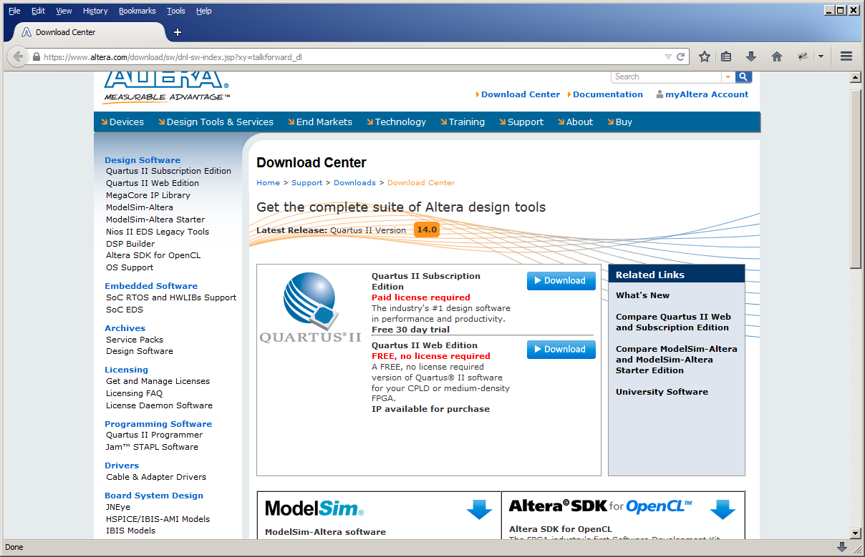

Then you can choos the version of the software. I suggest to choose the 13.1. version to avoid performance issues if your computer is not so powerful.

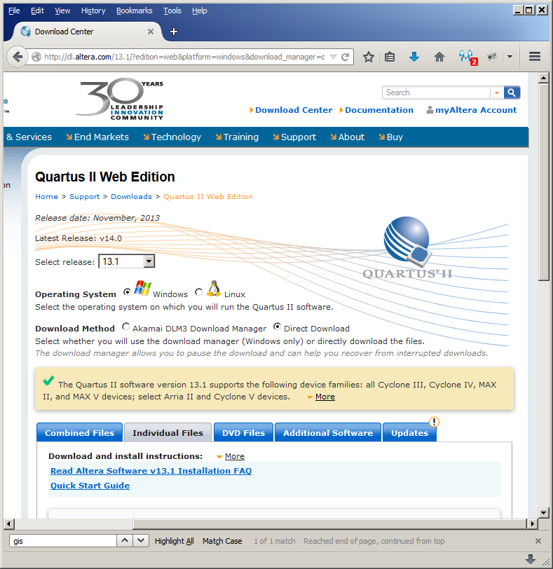

Download all the files shown on the download page.

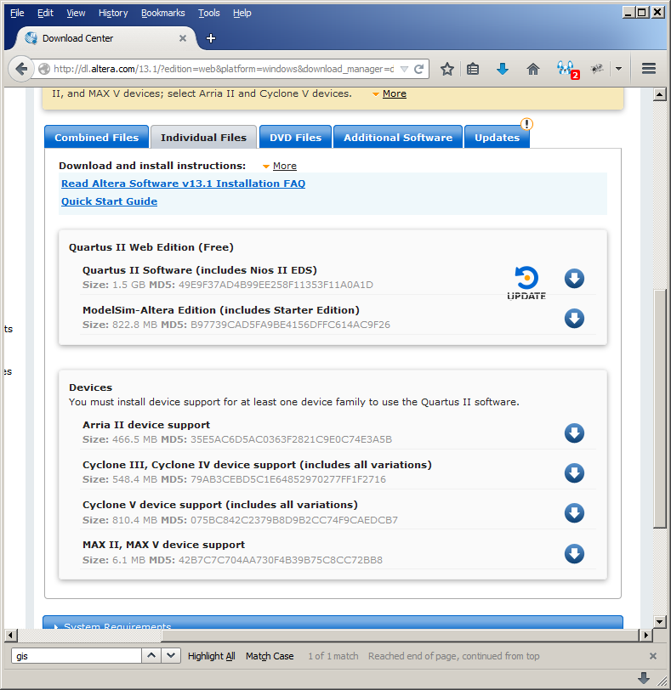

After downloading you’ll have the below list of files in your download directory.
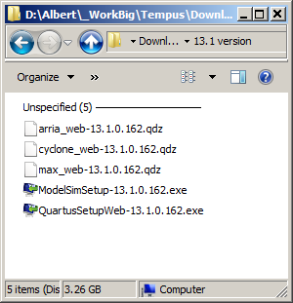

Run QuartusSetupWeb-13.1.0.162.exe and follow the installation steps. Mainly the default values of installation options are OK.

Running the software

Open the start menu and click on the “Quartus II 13.1 (64 bit)” menu item to launch the program as shown on below picture. If your windows system is not 64 bit then possibly you’ll have another name for your launching menu item.

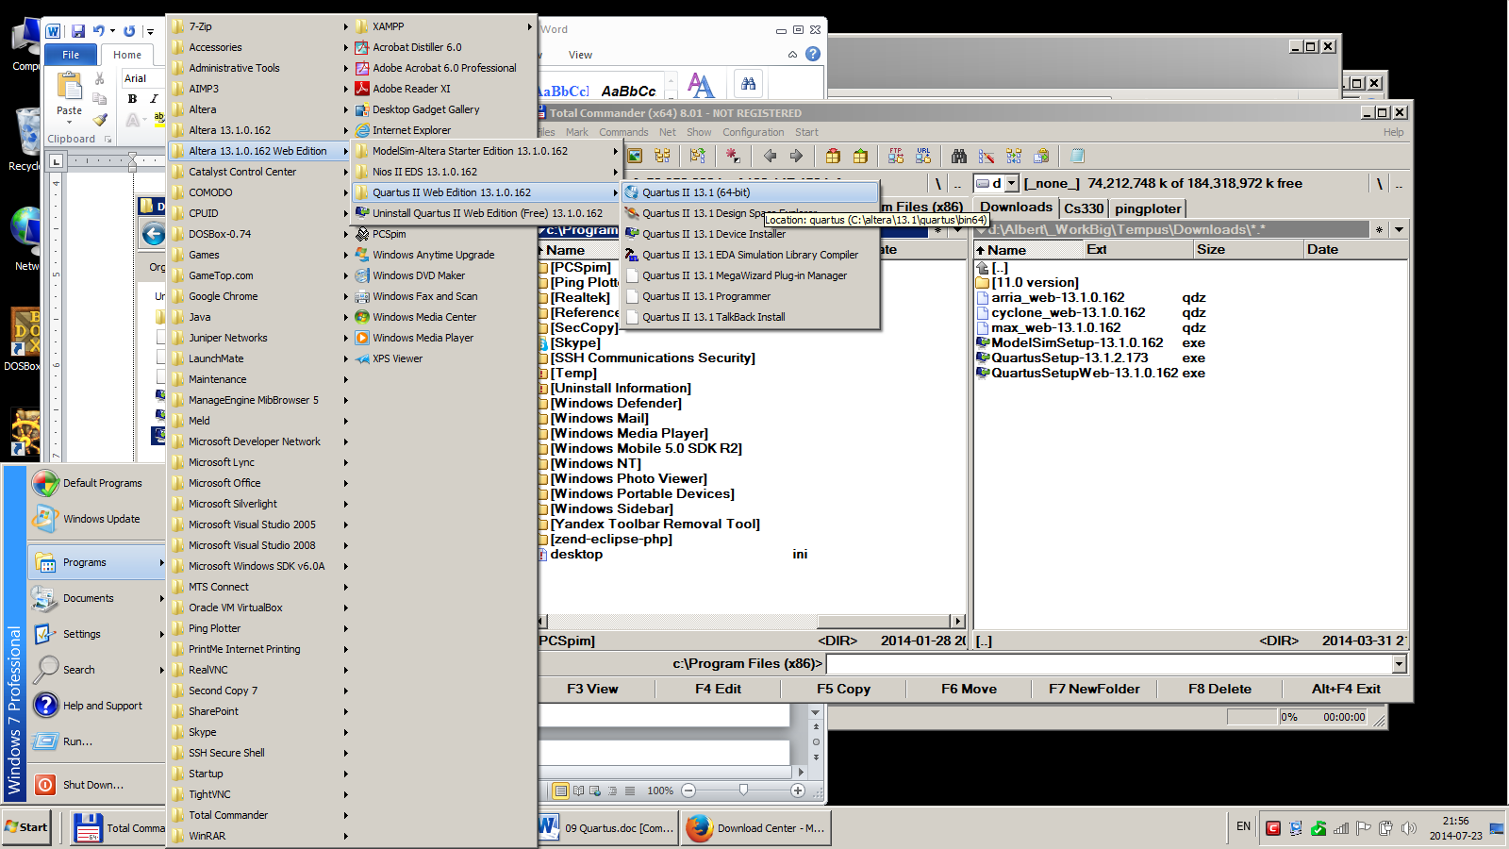

Project creation using the wizard

After launching of the Quartus you have the below window. You have to create a project to be able to start the design process.
Start to create a new project as shown below.
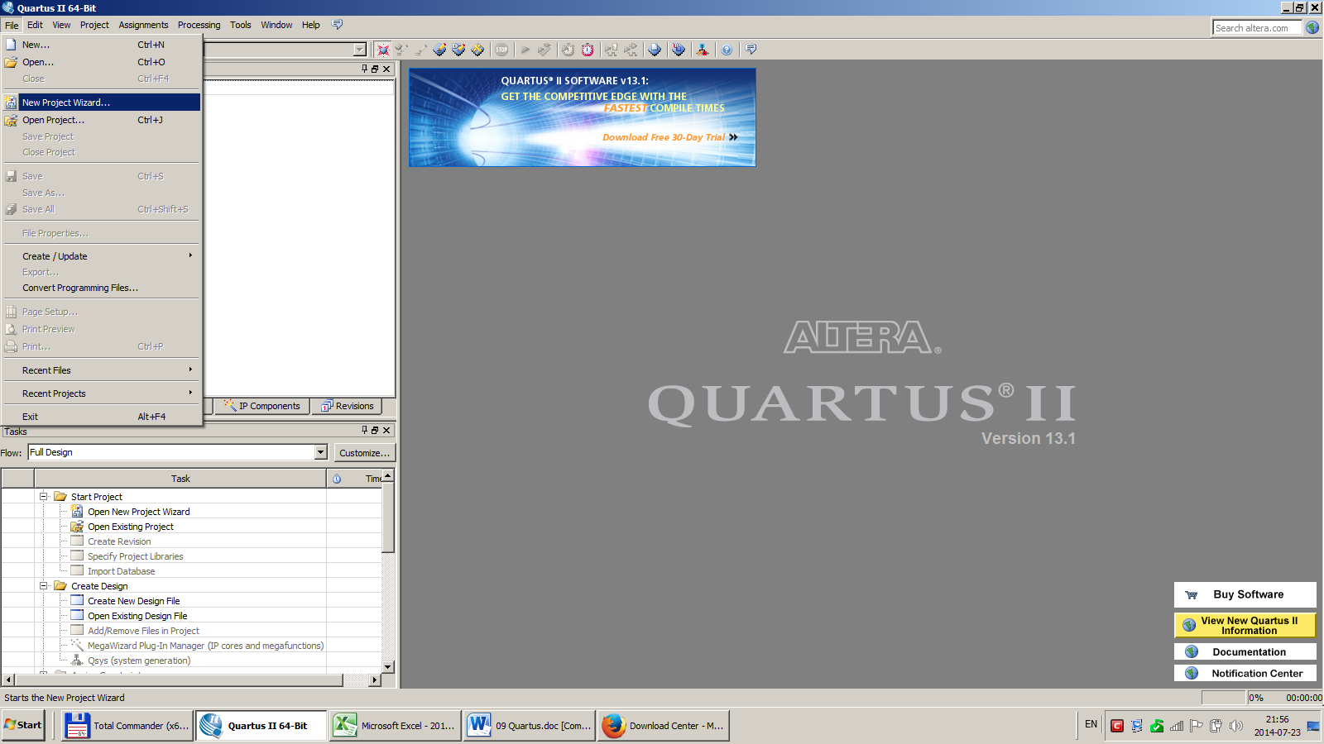
Simply press Next on this introductory screen.
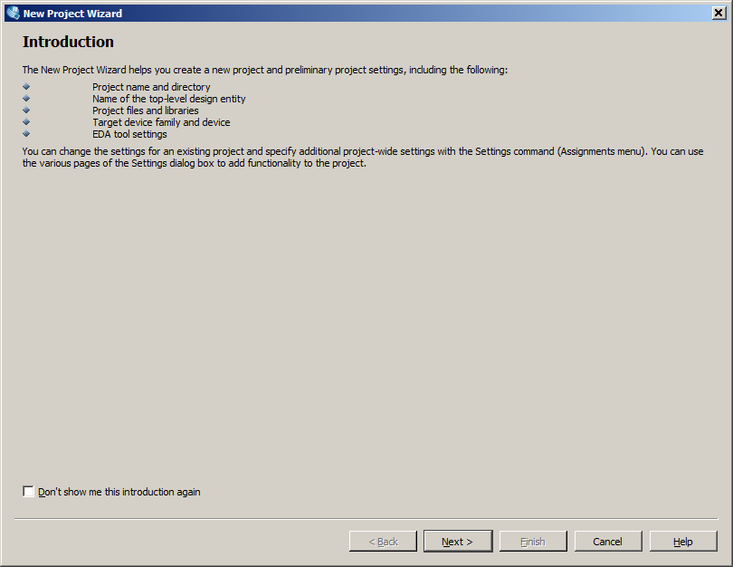

Choose some working directory for your project and the name for your project.

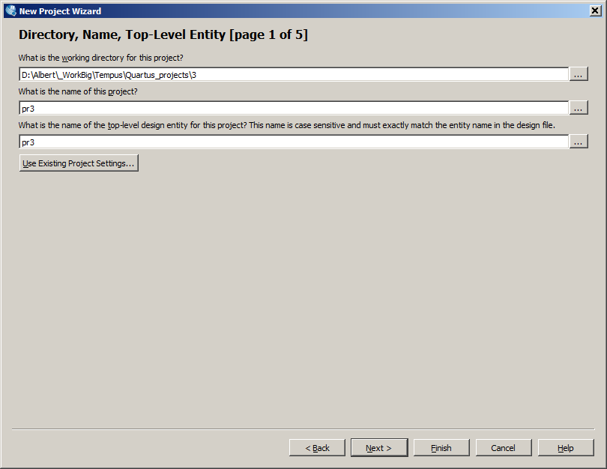

Chosoe “yes” to create the new project directory.

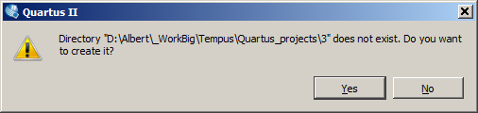

Simply press “next” to go to the next screen. No need yet to add any files to the project.

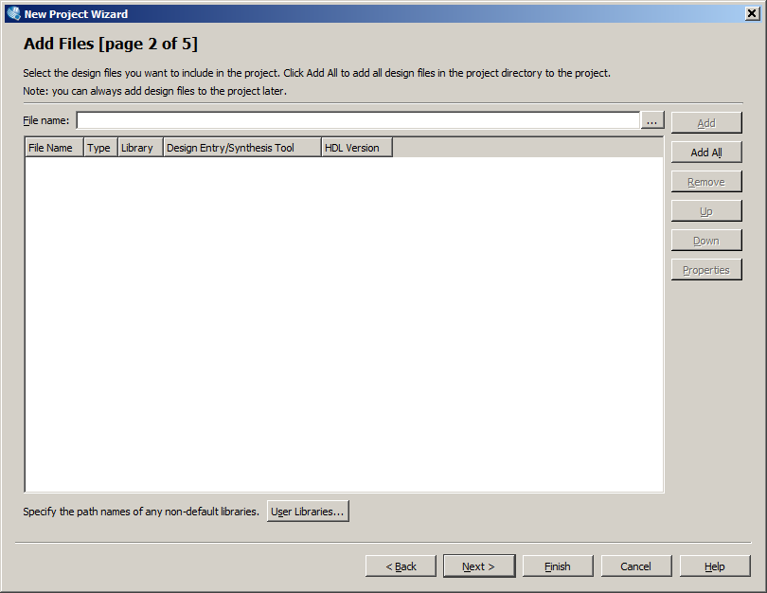

Choose the Device Family and the Device as shown on the below screen. That device is the fpga chip on the rapid prototyping board of GOLDI lab where we are going to implement our design.

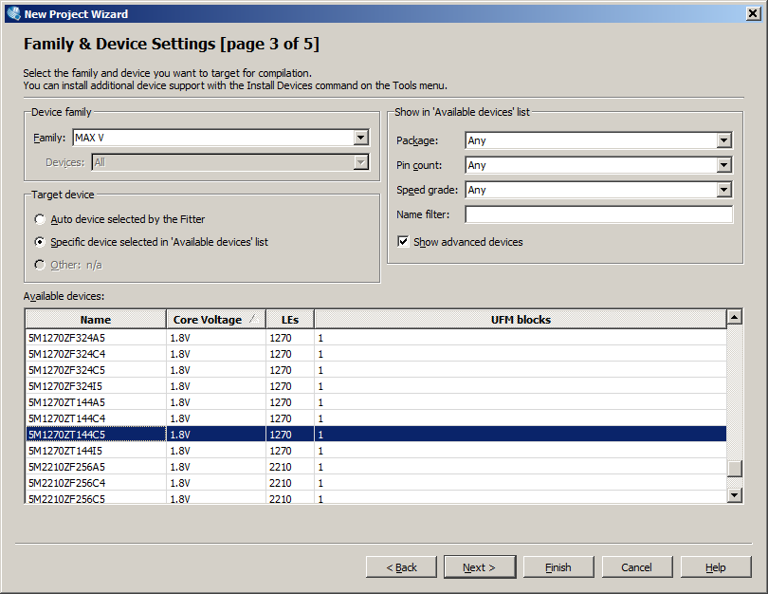

No changes are needed on the next screen. Just press “next”.
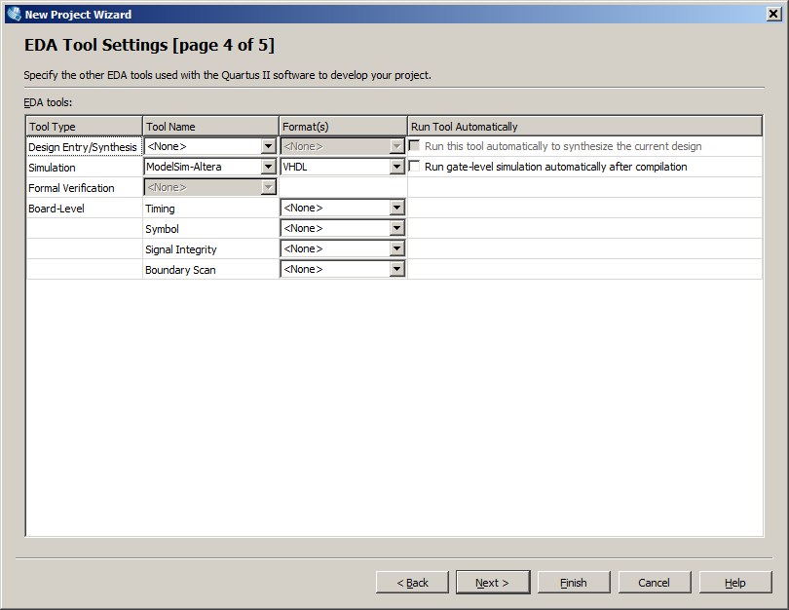
Visually verify the information you have entered on the previous screens of the wizard and press “finish”.

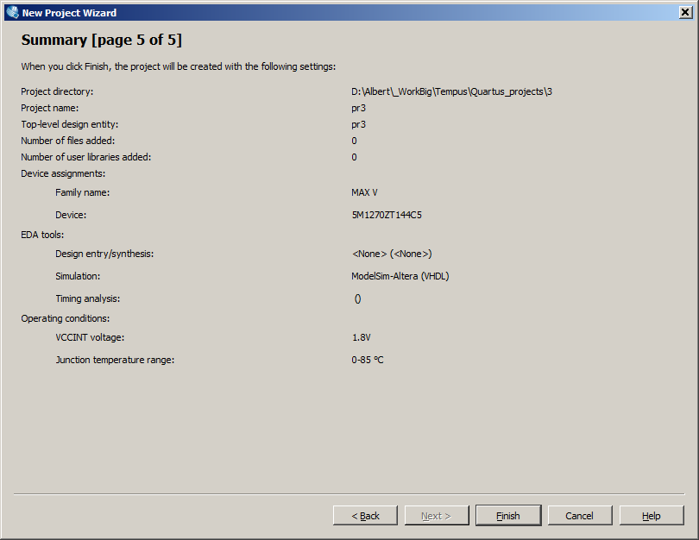

Now you have created the project and you can see it on the screen by the name you have chosen for it.

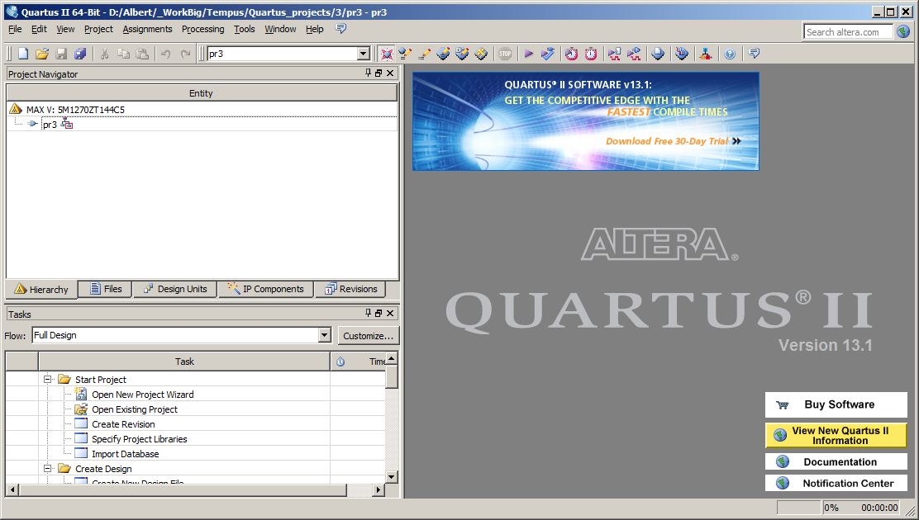
Start your design – create the schematic of the circuit

When the project is created you can start your circuit design. Below are described the steps how to create the schematic for your logical circuit.

Select “New” from the “File” menu item.

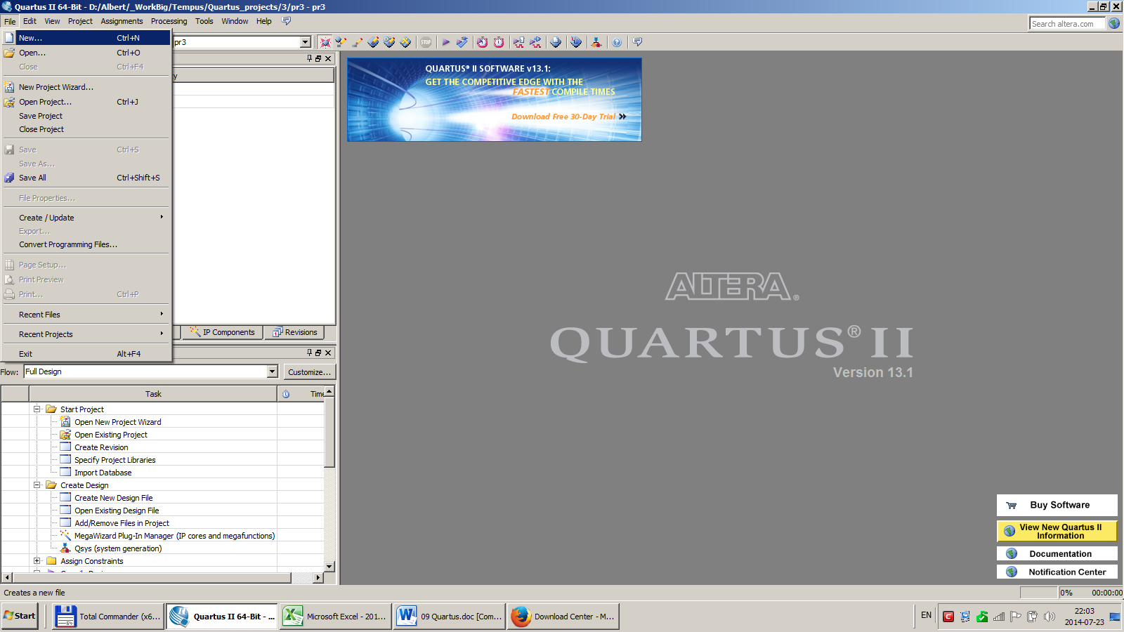

You’ll see the new window where you can choose which type of document you want to create. Choose the line “Block Diagram/Schematic File” and press OK.

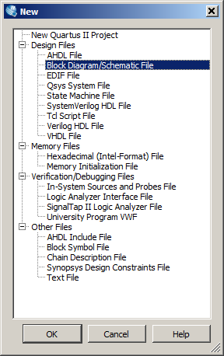
You’ll see the white space with the grid on the right part of your Quartus window.
That is the place “canvas” where you should create your schematic.

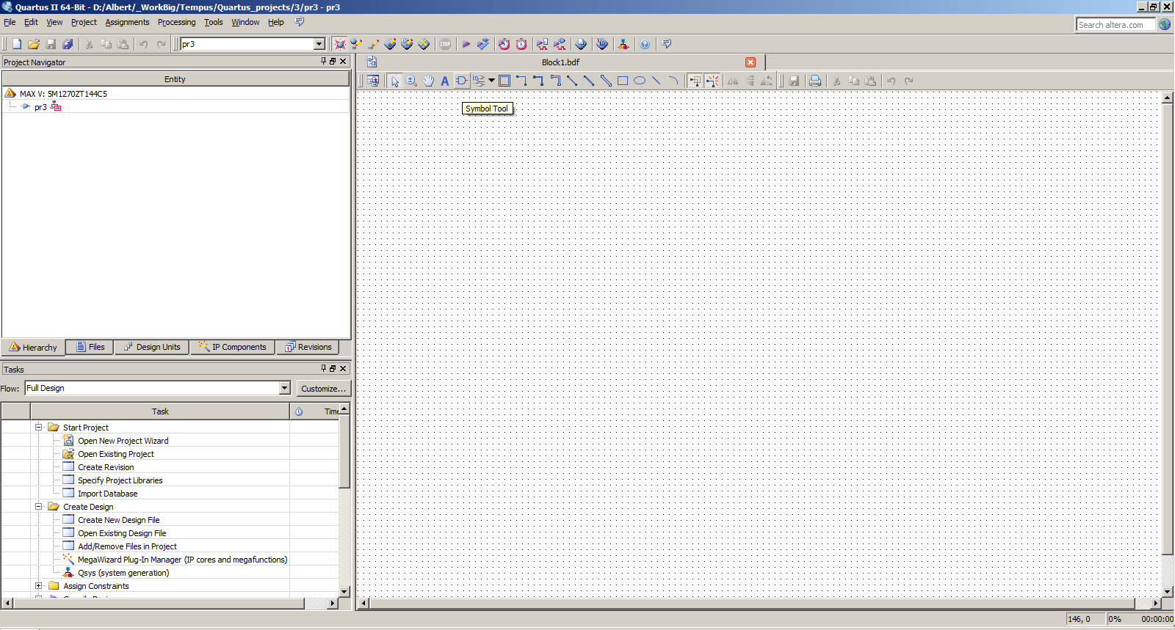
Canvas

Right click on the canvas and select “instert symbol” menu item. The below widnow appears. Expand the folder on the left/top part of the window to find the logic elements and other components of your schematic. Select the needed element. It will appear on the small canvas of this window. Then press OK to close the symbol window and move the selected element to the main canvas.

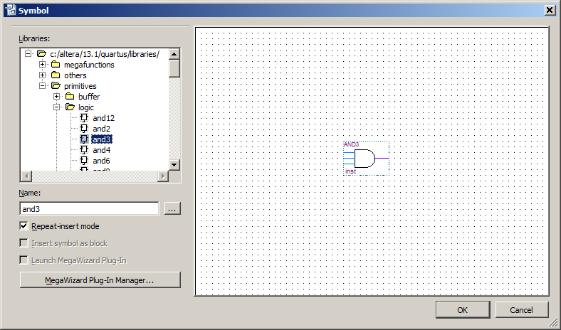
Select as many elements as you want for your schematic and connect them appropriately. When you hold your mouse over the elements’ inputs and outputs the program hints you how you can connect them. To check if you have connected properyly the elements try to move the element on the canvas. Then if the connections are made properly the connectins’ lines (shown by red arros on the schematic) should not be broken during the moving of the elements but will follow them.s

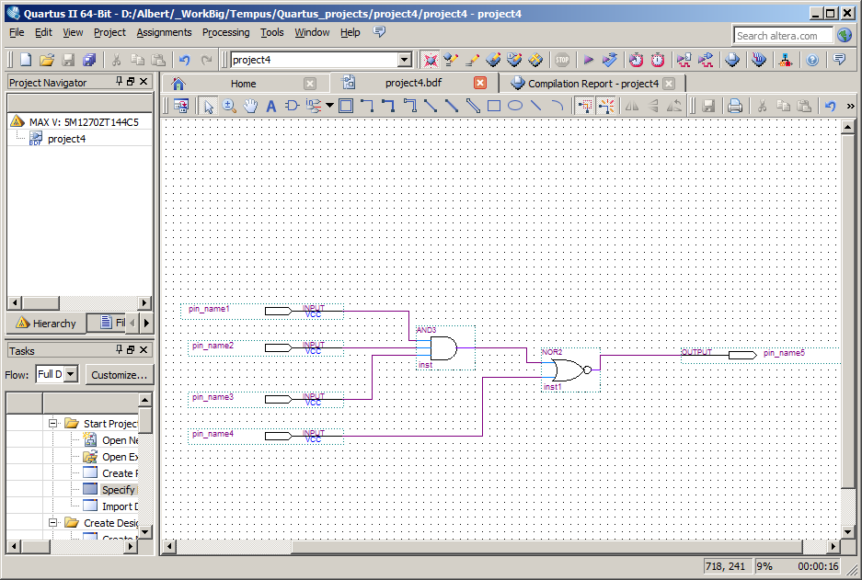

You should create “inputs” for your schematic to give it signals and should create “outputs” to look at the values of the signals going out of the circuit.

To create iputs and outputs use “pin tool” button on the toolbar as shown below then select input or output. After selection the output will appear on your mouse curson and you can put it at the appropriate place on your schematic.

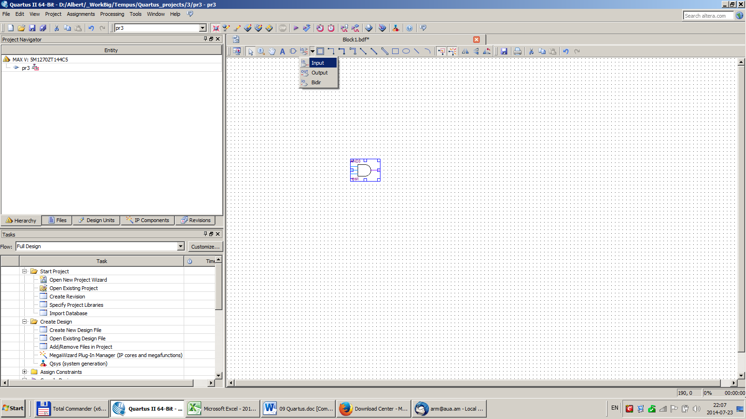

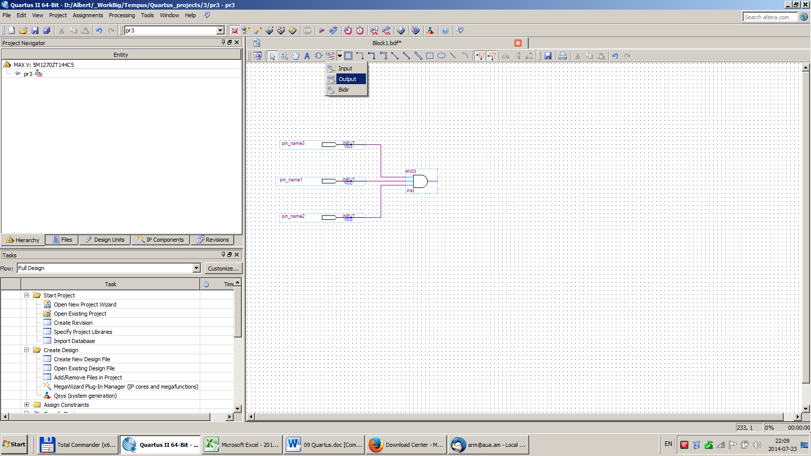

If your circuit is created then you need to save it to not lose your work. Will be well to save as often as you do significant changes on your project. Choose “File”, “Save” or “Save as” and choose the button “save”.

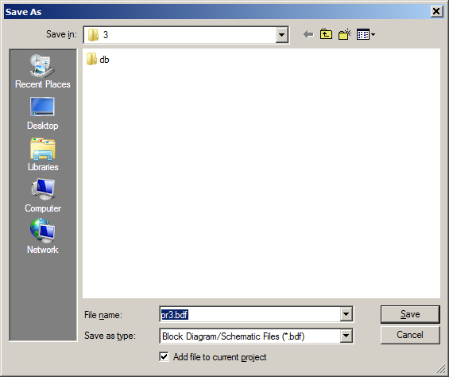

Now your project should be compiled to create all necessary data in the project to able later to do simulation. Choose “Processing” on toolbar then select “Start Compilation”.

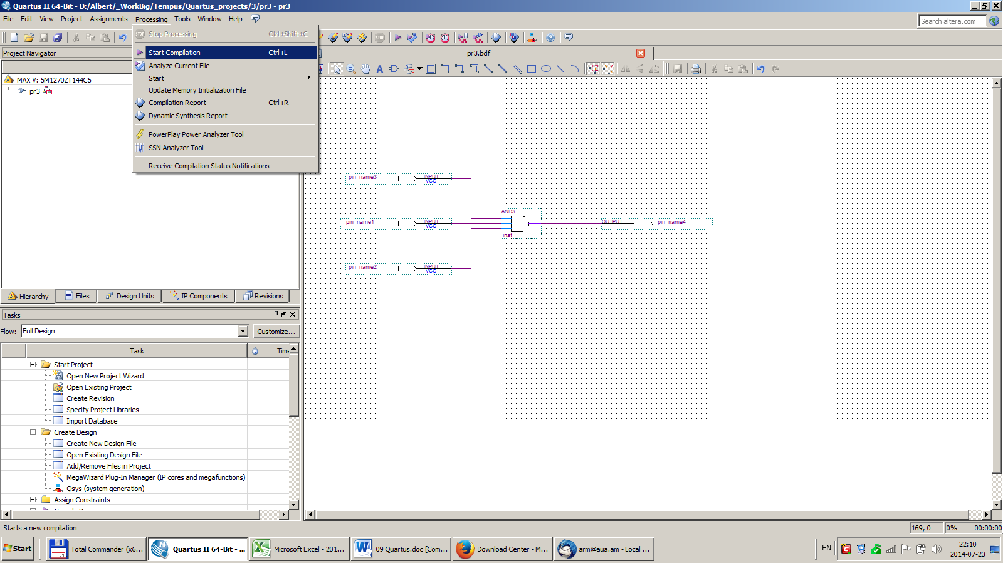

It’ll take a while but finally you’ll get this screen. Choose “Tools”, “Run Simulation Tool” then “Gate level simulation”.

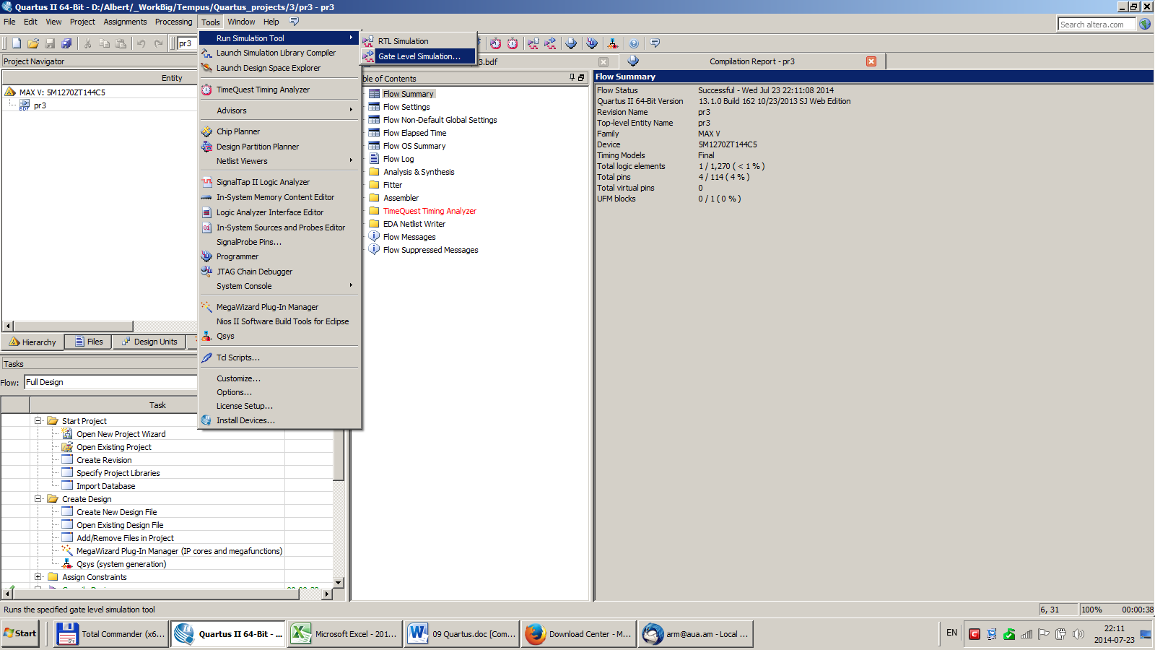

On this dialog leave the default “Slow Model” and press “Run”.

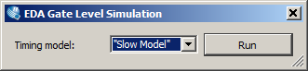

The Quartus Program will call the ModelSim simulator and open new window where you can start the simulation.

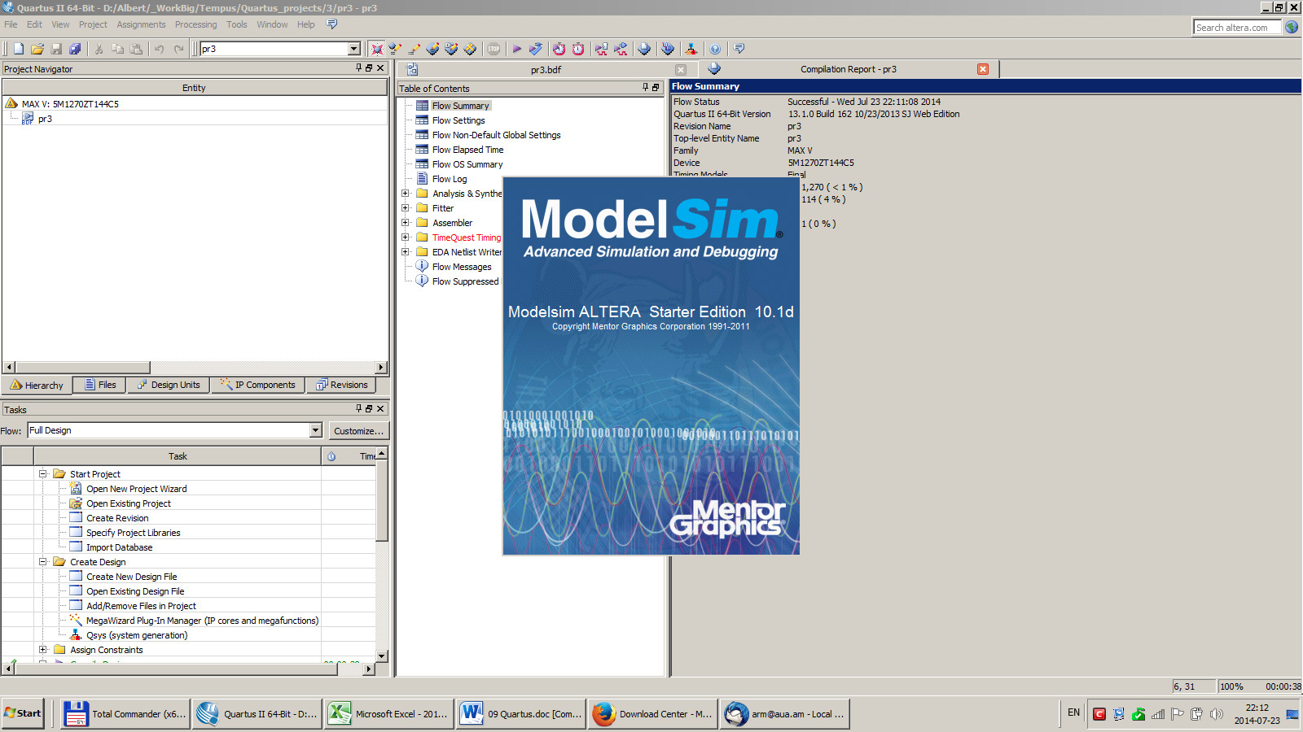

This is the ModelSim simulator screen called from the Quartus to simulate your circuit’s behavior.

